Tracking Api Document

Url:-<https://dev.skart-express.com/api/Booking_api/getTrackingData>

|  |  |  |  |
| --- | --- | --- | --- |
| Field | Data Type | Optional/Required | (Example) |

|  |  |  |  |
| --- | --- | --- | --- |
| airwaybilno | String | Required | 395004456020 |

Note:-Use Basic Authentication Like (ie username and password)

Request:-add your airwaybillno Like (ie 395004456020)

Response:- [

{

"awbno": "395004456020",

"status_code": "102",

"remarks": "Shipment information sent to FedEx",

"created_date": "2023-02-26 08:01:41"

},

{

"awbno": "395004456020",

"status_code": "90",

"remarks": "Shipment Booked",

"created_date": "2023-02-24 15:41:20"

}

]

Note:-Please check given snapshot for postman

|  |  |
| --- | --- |
| **Link** | <https://dev.skart-express.com/api/Booking_api/getTrackingData> |
| **Response** | JSON format |
| **Authorization** | Required (Username and Password same username and password like franchisee) |

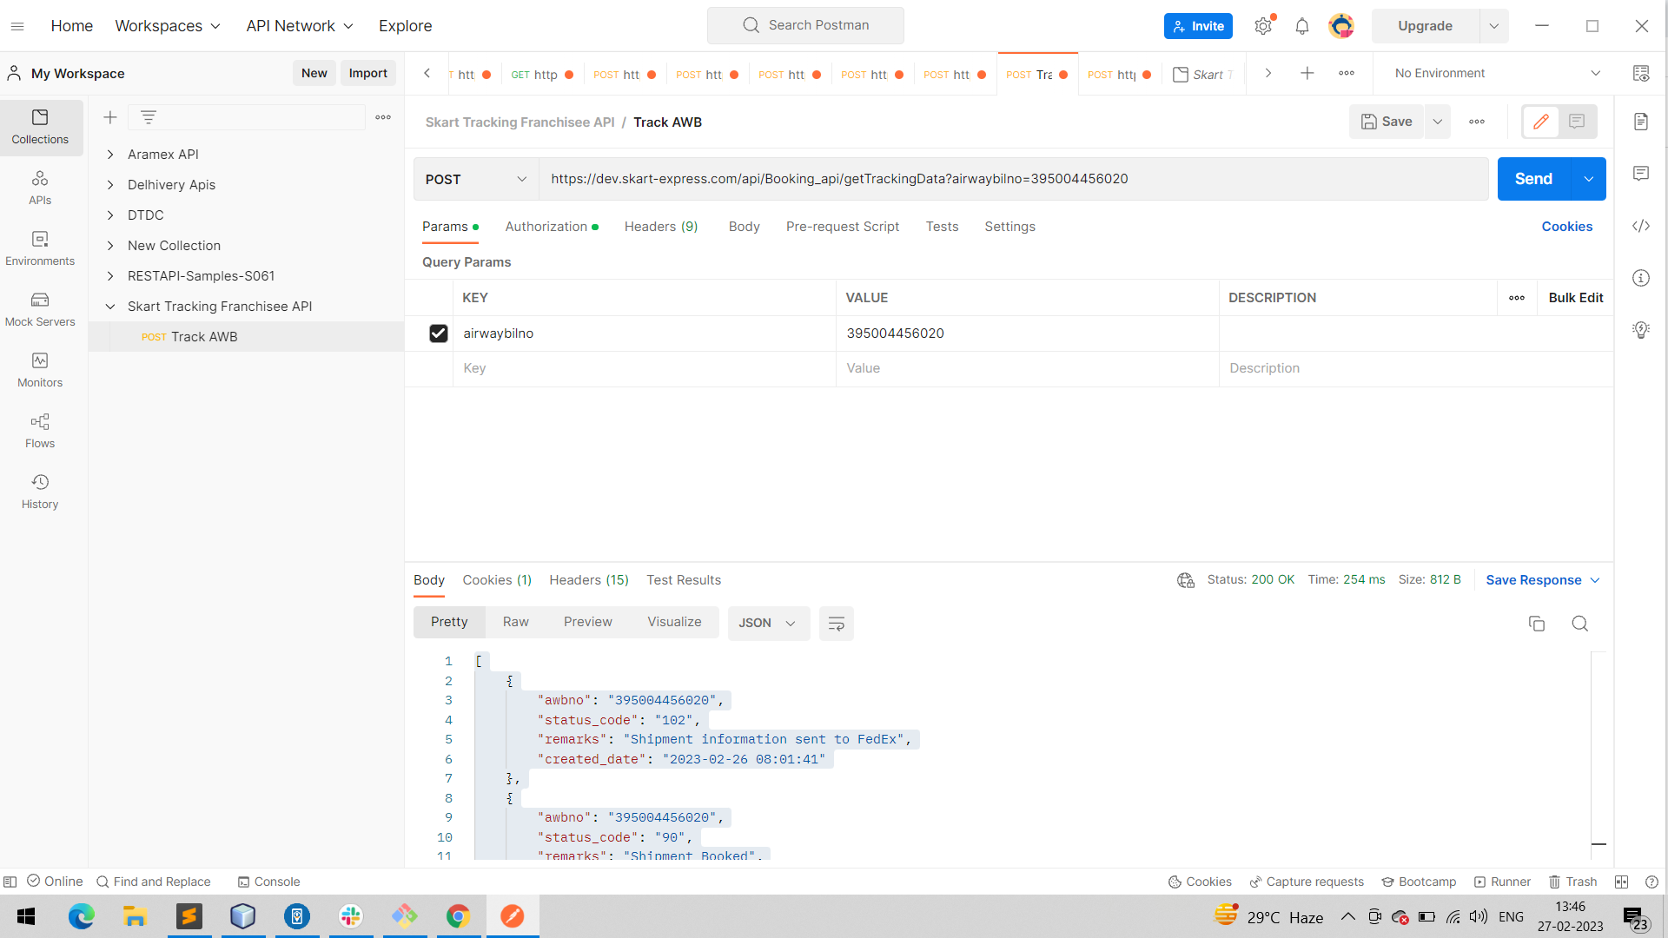

**SKART Internal Tracking Status Code**

|  |  |
| --- | --- |
| **Status Code** | **Remarks** |
| 90 | Shipment Booked |
| 91 | Manifested |
| 100 | Manifest In Scanned at Branch |
| 101 | Shipment In Scanned At Branch |
| 102 | Short Shipment |
| 103 | Segregated & Processing completed at Branch |
| 104 | Incomplete paperwork |
| 105 | Packaging is unworthy of transportation. Need repackaging |
| 106 | Shipment Inserted in Bag at Branch |
| 107 | Manifest Generated at Branch |
| 108 | Onforwarded to Courier Partner |
| 109 | Onforwarded to HUB |
| 110 | Released Held Up Shipment |
| 111 | RTO Initiated |
| 112 | RTO Manifested |
| 114 | Weight Variation |
| 150 | RTO Delivered |
| 151 | Bag Closed at Branch |
| 161 | Contents not allowed in courier mode |
| 162 | Change of service provider |
| 163 | Request from shipper to return shipment |
| 200 | Manifest In Scanned at HUB |
| 201 | Bag In Scanned At HUB |
| 202 | Shipment In Scanned At HUB |
| 203 | Short Shipment |
| 204 | Documentation Prepared |
| 205 | Incomplete paperwork |
| 206 | RTO Initiated |
| 207 | Weight Variation |
| 208 | Shipment Inserted in Bag at Hub |
| 209 | Manifest Generated at HUB |
| 210 | Handed over to Courier |
| 213 | Shipment Reversed |
| 251 | Bag Closed at Hub |
| 260 | Shipment received in damaged condition |
| 261 | Content are unsendable |
| 262 | Change of service provider |
| 263 | Request from shipper to return shipment |
| 300 | Released from Customs |
| 301 | Held in Customs - Inspection |
| 302 | Held in Customs - Inadequate Paperwork |
| 303 | Held in Customs - Other Reasons |
| 304 | In Transit to Destination |
| 305 | In Transit Delay -- Offload |
| 400 | Delivered |
| 401 | Partial shipment received |
| 402 | Under Custom Clearance |
| 403 | Held in Customs - Inspection |
| 404 | Held in Customs - Inadequate Paperwork |
| 405 | Held in Customs - Other Reasons |
| 406 | Held in Customs - Duty confirmation |
| 407 | Released from Customs |
| 500 | Bag In Scanned At Destination HUB |
| 501 | Shipment In Scanned At HUB |
| 502 | Damaged |
| 504 | Shipment Returned to sender |